**Feasibility Study for FitON System**

The **FitON System** is a mobile and web-based application suite aimed at revolutionizing the online shopping experience by offering virtual try-ons using user-uploaded images. This feasibility study assesses the viability of the FitON system across multiple dimensions: economic, operational, technical, cultural, and legal. A thorough evaluation of these areas is essential to determine whether the project is worthwhile from a financial, operational, technological, cultural, and legal standpoint.

**4.1. Economical Feasibility (MONEY)**

**1.1 Definition**

Economic feasibility primarily concerns the financial viability of the FitON system. This dimension assesses whether the investment required to develop, deploy, and maintain the system is outweighed by the expected revenues and cost savings. A positive economic feasibility indicates that the project will not only recover its costs but will also generate a sustainable profit.

**1.2 Study**

To evaluate economic feasibility, a **cost-benefit analysis** is essential. The analysis helps quantify the financial resources required for system development and compare those costs with the projected financial returns. This will involve estimating development costs, operational costs, and potential revenue streams.

* **Development Costs:** The development costs will include salaries for the development team, which consists of mobile developers, backend engineers, AI specialists, and designers. Additionally, tools, software licenses, and cloud hosting services (e.g., Supabase) must be factored into the costs.
* **Operational Costs:** Once the system is deployed, ongoing operational costs will include server maintenance, cloud storage, data processing for AI models, customer support, and periodic updates to the system. AI processing will be a recurring cost due to the image analysis and recommendation engines running in real-time.
* **Revenue Sources:** The primary revenue sources for FitON will include:
  + **Subscription Plans:** Offering premium features for buyers and sellers, such as advanced recommendations, exclusive access to certain products, or a personalized virtual try-on experience.
  + **Seller Commissions:** Sellers will pay a commission on each sale made through the platform. The commission rate will depend on the transaction value and the seller's membership level.
  + **Advertisements:** Displaying advertisements from third-party companies within the app could provide additional revenue. These ads can be tailored to user preferences and the types of clothing they are likely to purchase.

**1.3 Example – Outline Budget**

* **Initial Development Costs:** $XXX,000 for app development, including design, programming, and AI model integration.
* **AI Model Integration:** $XXX,000 for training and deploying the virtual try-on models and recommendation engine.
* **Marketing & Promotions:** $XXX,000 for user acquisition campaigns, influencer marketing, and social media ads to promote the platform to potential buyers and sellers.

**4.2. Operational Feasibility (KNOWLEDGE)**

**2.1 Definition**

Operational feasibility addresses whether the FitON system can be successfully integrated into the existing operational environment. It examines the processes required to maintain the system, train users and staff, and provide ongoing support. This dimension is critical to ensuring that the system can be utilized effectively by all stakeholders, including customers, sellers, and administrators.

**2.2 Study**

For FitON, operational feasibility includes evaluating the processes involved in the onboarding of users, training of sellers, and support for both users and sellers. Without proper training and support, the adoption of the system could be slow, and users might not fully leverage its capabilities.

* **Onboarding:**  
  Users will need a smooth onboarding experience to ensure they understand how to upload images for virtual try-ons and how to navigate the app. This will be facilitated by step-by-step tutorials, FAQs, and onboarding videos.
* **Training Sessions for Sellers:**

Sellers will require training to efficiently manage their inventory, process orders, and handle customer inquiries. FitON will provide video tutorials, knowledge bases, and live chat support to ensure sellers can maximize their use of the system.

* **Support System:**

A dedicated support team should be available to handle customer queries related to the virtual try-on process, payments, and product returns. Additionally, a ticketing system or live chat feature will allow users to quickly resolve any issues.

**2.3 Example – Implementation of Support and Training Systems**

* **For Users:** A well-designed tutorial will explain how to upload images for virtual try-ons, select clothing, and complete purchases. A 24/7 support team will address any issues related to the app’s functionality or payment processing.
* **For Sellers:** Sellers will receive in-depth training on managing their shop, updating inventory, and fulfilling orders. Training will be provided via webinars, documentation, and one-on-one sessions with a FitON representative.

**4.3. Technical Feasibility (HARDWARE & SOFTWARE)**

**3.1 Definition**

Technical feasibility determines whether the system can be developed and implemented using the available hardware and software resources. It also evaluates whether the technology chosen can handle the system’s demands and scale as the user base grows.

**3.2 Study**

The technical feasibility study for FitON involves evaluating the technologies that will power the system, including mobile development frameworks, backend services, and AI tools. The system will be developed using **Flutter** for the mobile apps, **Supabase** for the backend, and **GitHub** for team collaboration.

* **Hardware Requirements:**
  + **Cloud Servers:** FitON will rely on cloud infrastructure to process and store large image files and run AI models for virtual try-ons. These servers must be able to handle peak loads during sales events or seasonal spikes.
  + **User Devices:** The FitON app should be compatible with a range of user devices, including smartphones, tablets, and desktops. These devices must meet the minimum system requirements for the Flutter apps to run smoothly.
* **Software Requirements:**
  + **Flutter Framework:** Flutter will be used for building cross-platform mobile applications, ensuring consistency and efficiency in development.
  + **Supabase:** This will handle user authentication, real-time database updates, and backend storage.
  + **AI Models:** The integration of AI models for virtual try-ons and personalized recommendations will be a key component. These models require significant processing power, particularly when handling large datasets or generating recommendations in real-time.

**3.3 Example – Hardware and Software Integration**

* **Cloud Servers:** FitON will use scalable cloud infrastructure to support AI processing and image storage, with load balancing to ensure the system remains responsive even during peak usage.
* **AI Processing:** The AI tools used for virtual try-ons will require access to GPU-powered servers, especially when analyzing and processing user-uploaded images in real-time.

**4.4. Cultural & Political Feasibility (BACKGROUND)**

**4.1 Definition**

Cultural and political feasibility assesses how well the FitON system aligns with societal norms, corporate culture, and the political environment. It considers how the system might be perceived by users in different regions and whether it complies with local regulations.

**4.2 Study**

FitON must be designed to cater to diverse cultural preferences and avoid conflicts with political or societal norms. The system should align with user expectations, both in terms of functionality and ethics. Moreover, FitON must ensure that its features and advertisements are culturally sensitive.

* **Organizational Culture:**

FitON’s organizational culture should prioritize inclusivity, promoting diversity in fashion through AI-powered recommendations that cater to various body types, preferences, and styles.

* **Market Acceptance:**

In different markets, customer behavior and shopping habits can vary significantly. For example, some regions may have a strong preference for eco-friendly fashion, while others may prioritize fast fashion. FitON must adapt its marketing strategies and product offerings to meet local expectations.

**4.3 Example – Cultural Sensitivity**

* **Inclusivity in Fashion:**

FitON will focus on offering a wide range of sizes, styles, and clothing options to accommodate diverse users. AI recommendations will ensure that users see personalized, culturally relevant suggestions.

* **Market Research:**

FitON will conduct market research to understand how different regions approach online shopping and fashion, tailoring its marketing and features accordingly.

**4.5. Legal Feasibility (LEGAL)**

**5.1 Definition**

Legal feasibility involves assessing whether the FitON system complies with relevant laws, regulations, and policies. This includes data privacy laws, intellectual property protection, and e-commerce regulations.

**5.2 Study**

Given that FitON will handle sensitive user data, particularly images and personal information, it is crucial to ensure compliance with global privacy laws, including **GDPR** (General Data Protection Regulation) for European users. Intellectual property protection is also vital to safeguard uploaded content, AI models, and digital assets.

* **Privacy Laws:**

FitON must comply with data protection regulations, ensuring that user images and personal data are stored securely and only used for the purposes explicitly outlined in the privacy policy.

* **Copyrights:**

FitON will need to ensure that all intellectual property, including AI models, clothing images, and user-uploaded designs, is protected from unauthorized use or distribution.

* **E-commerce Regulations:**

FitON must adhere to online transaction regulations, including secure payment processing, order fulfillment, and refund policies.

**5.3 Example – Compliance and Legal Protections**

* **Data Privacy:**

FitON will implement end-to-end encryption and secure data storage to protect user images and personal details.

* **Copyright Protection:**

All uploaded designs and product images will be copyright-protected, with clear terms of service to ensure the legal use of content.

**Conclusion**

This feasibility study provides a comprehensive evaluation of the **FitON system** across economic, operational, technical, cultural, and legal dimensions. Each area has been carefully analyzed to ensure that the system is not only technically viable but also financially sustainable, operationally efficient, and legally compliant. By addressing these aspects early in the project, FitON can confidently proceed with development, knowing that the system meets the necessary requirements for success.

**4.6. Schedule Feasibility (TIME)**

**6.1.Definition.**  
Considering the efficiency of the development team, task dependencies, and resource availability, schedule feasibility assesses whether the project can be finished within the given timeframe. This evaluation guarantees that project completion dates are reasonable and attainable.

**6.2. Study.**

The team has implemented an Agile methodology, segmenting the project into several sprints and milestones, to guarantee that FitON is developed within the allotted time frame. Continuous progress monitoring, prompt adjustments, and iterative improvements based on feedback are all made possible by this structured approach.

To maintain an efficient workflow, the project adheres to the following key strategies:

* **Gantt Chart:** visual timeline that shows assigned work, dependencies, and progress checkpoints.

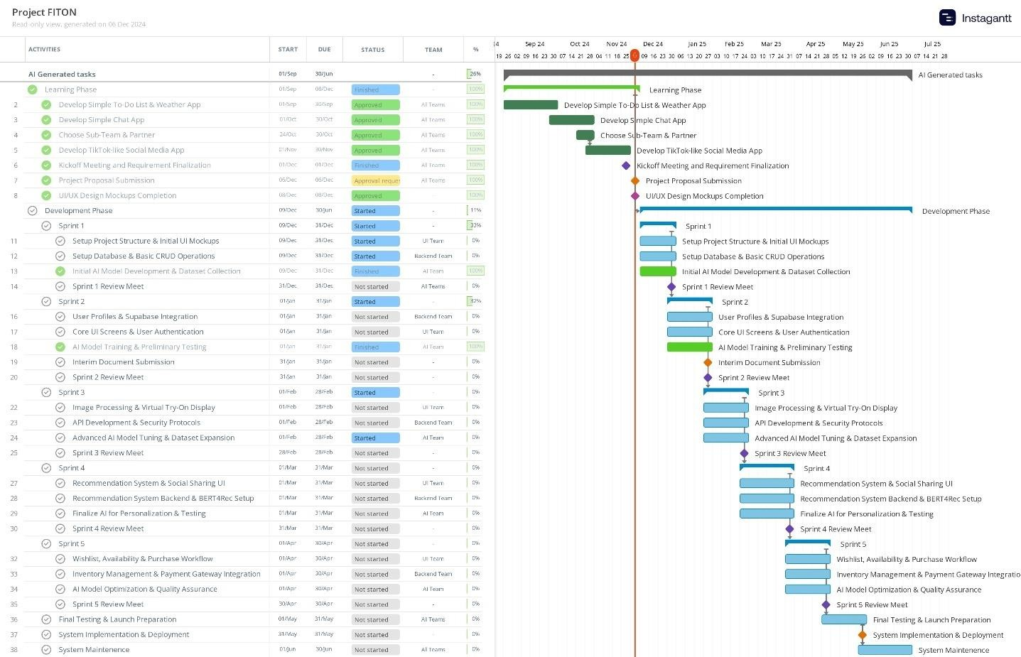

* *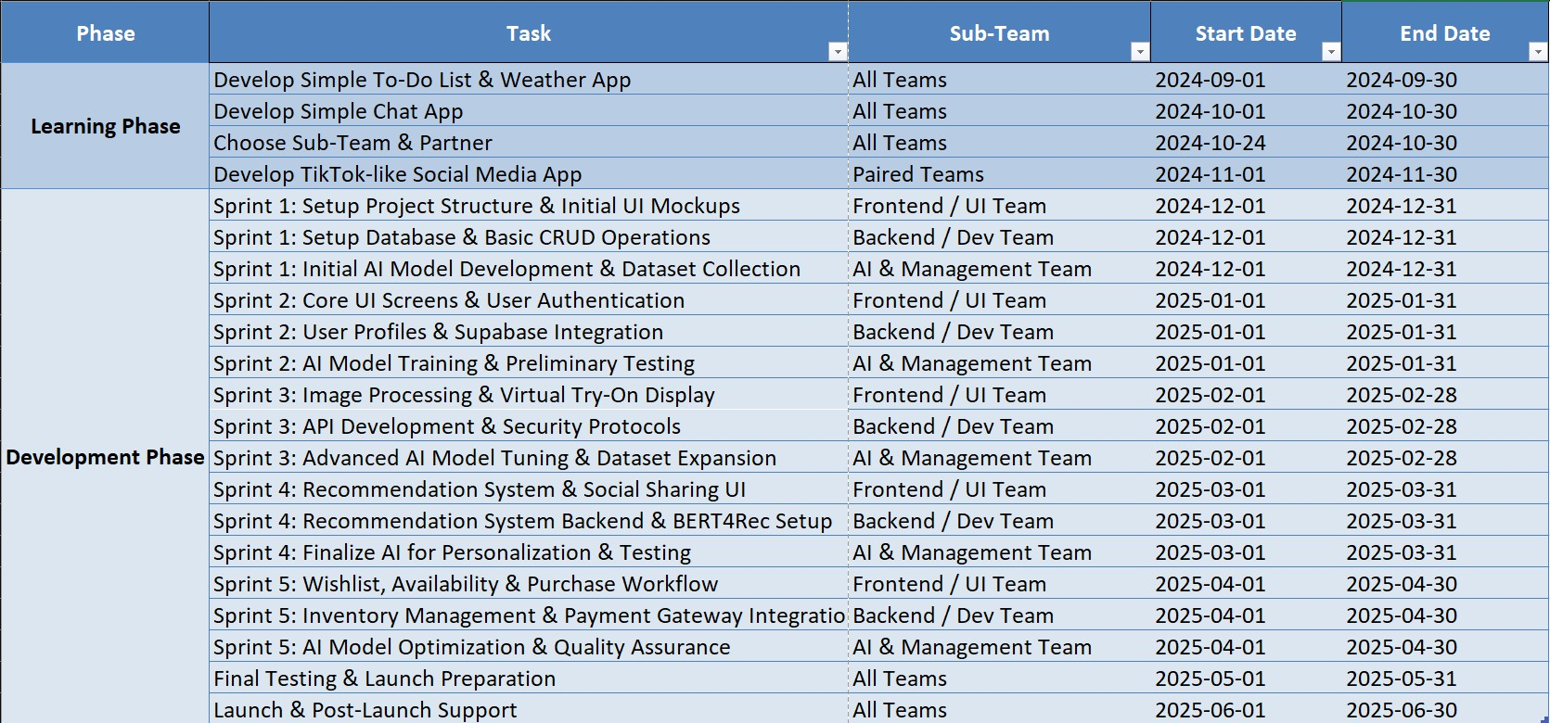***Teamwork Table**: A structured table outlining team members' responsibilities and deadlines.
* **GitHub Project Sprints**: Organized development cycles for efficient task completion and iteration.

* A screenshot of a computer

  AI-generated content may be incorrect.**GitHub Project Timeline**: Provides a graphical overview of project progress, including completed, ongoing, and pending tasks.

By following this structured development approach, the FitON team reduces delays, ensures timely feature rollouts,and keeps the project moving.

**4.7. Chapter Summary**

An essential part of project planning is a feasibility study, which helps businesses decide if a suggested concept is workable before spending time, money, and resources. It evaluates several variables, including operational needs, technological prowess, financial feasibility, and legal issues. Businesses may reduce risks, make wise decisions, and guarantee seamless project execution by carrying out a feasibility study.

**7.1 Positives (Advantages from Studying Feasibilities)**

There are several advantages to a well-executed feasibility study that help a project succeed. Before proceeding with implementation, it assists businesses in efficiently planning and reducing any risks.

* **Financial Viability**: By examining expenses, budgets, and possible returns on investment, a feasibility study makes sure a project is financially viable. This aids in obtaining capital and averting unforeseen deficits.
* **Operational Efficiency**: The research helps to simplify operations by addressing aspects such as onboarding, training, and support. This ensures a seamless implementation process and minimizes inefficiencies.
* **Technical Feasibility**: Assessing software and hardware needs guarantees that the project can be carried out using the technology currently in use. By doing this, compatibility problems and technical malfunctions are prevented.
* **Legal and Compliance Assurance**: By evaluating data privacy regulations, regulatory standards, and copyright concerns, the research lowers legal risks and makes sure the project complies with legal frameworks.
* **Structured Development Roadmap**: A feasibility study offers a precise schedule with well-defined checkpoints, guaranteeing efficient work management, scheduling, and progress monitoring.

**7.2 Negatives (Disadvantages from Studying Feasibilities)**  
Despite its benefits, carrying out a feasibility study has several drawbacks that businesses need to be aware of.

* **Time and Resource Demands**: Performing a thorough feasibility study takes a lot of time, knowledge, and effort, which might delay the start of the project as a whole.
* **Financial Uncertainties:** It might be challenging to forecast long-term financial viability due to unforeseen expenses or budgetary restrictions, even with meticulous planning.
* **Legal Complexities**: Maintaining adherence to rules and regulations may provide new difficulties, necessitating legal knowledge and constant observation to satisfy industry norms.
* **External Factors and Scheduling Risks:** A project's viability frequently depends on outside variables including the state of the market, developments in technology, and the availability of resources, all of which can affect project schedules and create delays.

For businesses to make well-informed decisions, lower risks, and increase project success rates, a feasibility study is crucial. However, to properly handle obstacles, careful planning and flexibility are needed.

**References**

Bilandzic, A.S. (2021) The rise of casual creative environments: Towards a socially embedded view of innovation precursors and processes.

Available at: [**https://doi.org/10.5204/thesis.eprints.207668**](https://doi.org/10.5204/thesis.eprints.207668).

(Bilandzic, 2021)

Batiste, S. et al. (2023) City Scripts: Narratives of postindustrial urban futures, The Ohio State University Press eBooks.

Available at : <https://doi.org/10.26818/9780814215524>.

(Batiste et al., 2023)

Abdullahi, M. and Usman, M.F. (2021) 'Marketing environment and Business Failure: A study of small and medium scale enterprises (SMEs) in Northern Nigeria,' The International Journal of Humanities & Social Studies, 9(6).

Available at : <https://doi.org/10.24940/theijhss/2021/v9/i6/hs2105-042>.

(Abdullahi and Usman, 2021)

Mazhandu, Z.S. et al. (2020) 'Integrated and Consolidated Review of Plastic Waste Management and Bio-Based Biodegradable Plastics: Challenges and Opportunities,' Sustainability, 12(20), p. 8360.

Available at: <https://doi.org/10.3390/su12208360>.

(Mazhandu et al., 2020)

Bostoen, F. and Mândrescu, D. (2020) 'Assessing abuse of dominance in the platform economy: a case study of app stores,' European Competition Journal, 16(2–3), pp. 431–491. Available at Available at :<https://doi.org/10.1080/17441056.2020.1805698>.

(Bostoen and Mândrescu, 2020)